Version 1 – Matériel

- RPI Model 3 – QuadCore – 1Gb de RAM
- Ecran LCD 3.5, Driver ILI 9486 – 320x480 – Touch – SKU:MPI3501
- Carte microSD - 16gb

Détail :

RPI :
«https://www.ebay.com/itm/Raspberry-Pi-3-Model-B-Quad-Core-1-2GHz-64bit-CPU-1GB-RAM-WiFi-Bluetooth-4-1/173483624666?hash=item28646e08da:g:aKAAAOSw2stberCj»

Ecran / Boitier

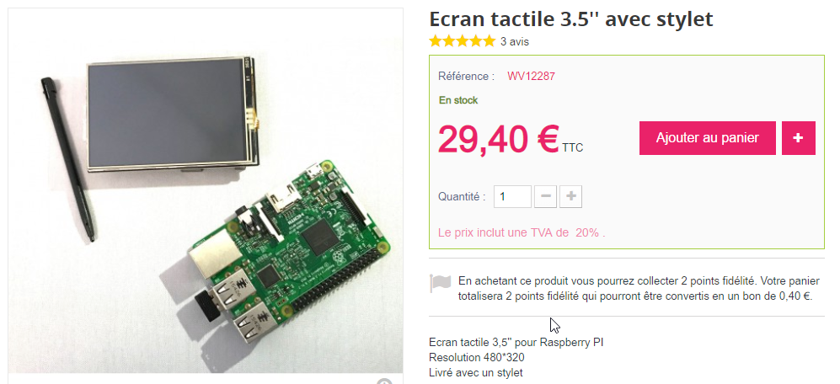
avec le boitier de protection :

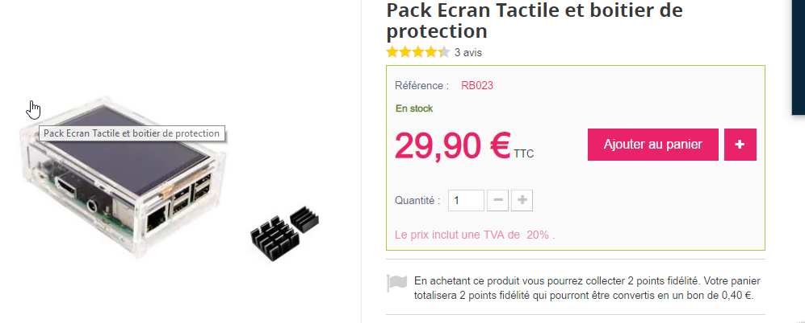
«https://www.ebay.com/itm/3-5-LCD-TouchScreen-Display-Raspberry-Pi-2-3-Model-B-Board-Acrylic-Case-Stylus/192321428818?_trkparms=aid%3D555018%26algo%3DPL.SIM%26ao%3D2%26asc%3D52885%26meid%3D314b3a69991c4d118d81347c60b0dd6d%26pid%3D100005%26rk%3D1%26rkt%3D12%26mehot%3Dpp%26sd%3D232774296543%26itm%3D192321428818&_trksid=p2047675.c100005.m1851»

All in One :

https://www.ebay.com/itm/Raspberry-Pi-3-Model-B-Starter-Complete-Kits-with-3-5-inch-display-heat-sinks/192505250845?epid=28019130443&hash=item2cd235041d:g:7q8AAOSw8YVayb8R

